**Name: Varad Patil  
PRN: 120A2036**

**EXPERIMENT NO. 08**

**STUDY OF DROPPING OF THE CHANNELS IN WDM LINK**

**EXPERIMENT NO. 08**

**STUDY OF DROPPING OF THE CHANNELS IN WDM LINK**

**OBJECTIVE:** The objective of this experiment is to

1. To setup an Optical Add Drop Multiplexer (OADM) using Fiber Bragg Grating and Circulator.
2. Determine dropping and transmission efficiencies of OADM.

**EQUIPMENTS:**

1. C-Band Lasers – 4
2. InGaAsPhotodetectors
3. Fiber Bragg Grating (1550 nm)
4. 4 Channel Mux
5. Optical Circulator
6. Optical Power meter

**FORMULA USED:**

Transmission and dropping efficiency in db = 10log(P2/P1) where P1 and P2 are the input and output optical power before and after transmission/dropping respectively.

**THEORY:**

**Optical Add Drop Multiplexer**

Optical Add Drop Multiplexer (OADM), mainly deployed in wide area and metro area network, is used for adding and dropping of optical channels in a fiber link while preserving the integrity of the channels. Several kinds of OADMs which uses a MachZehnder Interferometer. However, grating assisted directional coupler, Arrayed Waveguide Grating (AWG) based OADM and Optical circulator based OADM are widely used. In the present experiment Optical Circulator based OADM is employed whose basic architecture is detailed in figure.

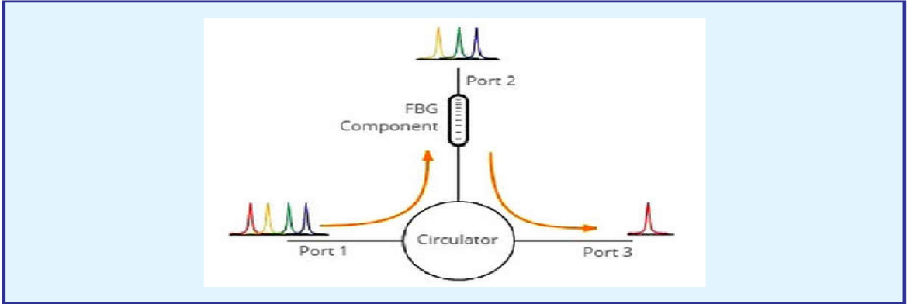

OADM Architecture using FBG and Optical Circulator

**PROCEDURE:**

1. Setup the LIGHT RUNNER as per the instructions given in the manual.
2. Select the corresponding experiment from the experiment drop down menu with the help of stylus and the experimental window will appear on the screen.
3. Connect the 1550 nm laser source and any other C-band laser source (say 1530 nm) to the respective ports of the MUX by using patch cords.
4. Connect the OUT port of the MUX to anyone of the of the InGaAs (say PD3) photodetector with the help of the patch cord.
5. Now connect the BNC connector adjacent to PD3 to anyone channel (say CH1) of the DSO with help of BNC cable.
6. Enable both the lasers and set the different parameters for both the lasers (say for 1550 nm laser :- frequency = 50%, duty cycle = 10%, power = 85% and for 1530 nm, laser:- frequency = 50%, duty cycle = 50%, power = 40%) for their identification purpose.
7. Click on the ‘Start’ button, a multiplexed waveform will appear on the screen.
8. In case of detector saturation, set the laser power level below the saturation level.
9. Determine the optical power of each signal with the help of power meter and consider it as P1.
10. Now connect the ‘OUT’ port of the multiplexer to the port 1 of the circulator. The combined laser light at Port 1 comes out at Port 2 which is fed to FBG through patch cord.
11. Since FBG has a characteristic reflection wavelength at 1550 nm, therefore the 1550 nm light reflected from the FBG comes back into Port 2 and is dropped by the circulator at Port 3.
12. Connect the port 3 of circulator to PD3. The dropped signal can be seen on the screen by making connection through BNC cable to CH1 of the DSO.
13. Disconnect the patch cord from PD3
14. From the above two measurements, determine the dropping efficiency of the signal by using the given formula.
15. The 1530 nm light at one end of FBG, instead of reflecting back like 1550 nm, passes through the FBG and appears at its other end which can be measured using same PD3 and DSO.
16. Connect the other end of FBG to PD3. The transmitted signal can be seen on the screen by making connection through BNC cable to CH1 of the DSO.
17. Disconnect the patch cord from PD3 and measure the optical power of the transmitted signal with the power meter, consider it as P2.
18. From the above two measurements, determine the transmission efficiency of the signal by using the given formula.
19. Repeat the above experiment for other combinations (1510-1550 and 15501570) also.

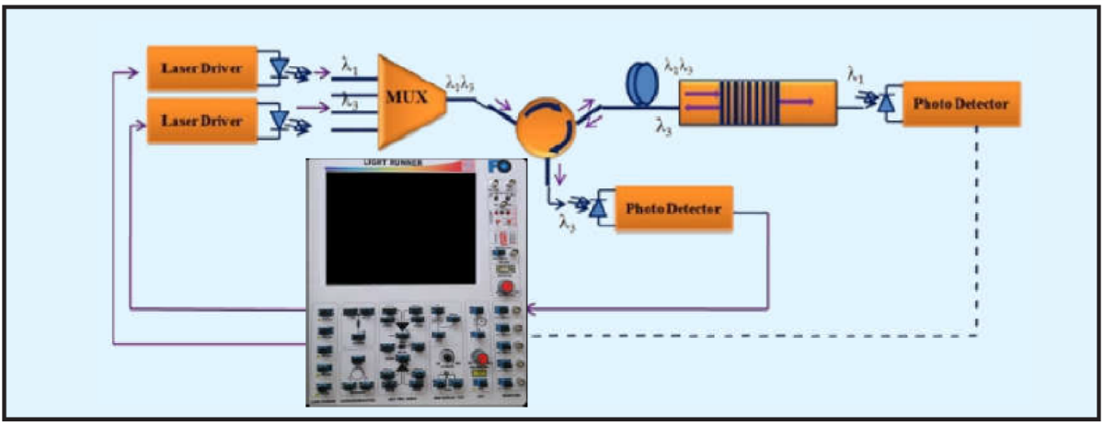

Schematic of experimental setup for Dropping of channels in an OADM. Solid lines represent current use and the dotted line later use.

**OBSERVATION:**

Estimation of dropping and transmission efficiency

|  |  |  |  |  |  |
| --- | --- | --- | --- | --- | --- |
| Sr. No. | Channel  Wavelength  (nm) | Optical power before OADM,  P1 (µW) | Optical power after OADM,  P2 (µW) | Dropping efficiency for λ3 (1550 nm) in dB = 10  log(P2/P1) | Transmission efficiency for λ1, λ2 and λ3 in dB = 10  log(P2/P1) |
| 1 | 1510 | 26 | 2 | - | 11.13 |
| 1550 | 83 | 13 | 8.05 | - |
| 2 | 1530 | 93 | 11 | - | 9.27 |
| 1550 | 83 | 13 | 8.05 | - |
| 3 | 1570 | 141 | 22 | - | 8.06 |
| 1550 | 83 | 14 | 7.72 | - |

**CONCLUSION:**

From the above experiment we can observed that the smaller channel wavelength were dropped. The FBG was designed such that it reflects only 1550nm wavelength. Dropping efficiency decreases when wavelength is more that 1550nm and transmission efficiency decreases for increasing wavelength. The experiment was performed successfully.